DNS AAAA Record

🟪 What is a DNS AAAA Record?
# Source: Chatgpt (GPT-5-Mini) at [1/18/2026]
A DNS AAAA Record (pronounced "quad-A record") maps a domain name to its corresponding IPv6 address.
🧠 It tells the internet:
"For this domain name, here’s the IPv6 address to connect to."

🔍 Details of AAAA Record
# Source: Chatgpt (GPT-5-Mini) at [1/18/2026]
- Purpose: Translates a domain name (e.g., example.com) into a 128-bit IPv6 address (e.g., 2606:2800:220:1:248:1893:25c8:1946).
- Format:
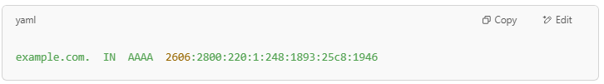
example.com. IN AAAA 2606:2800:220:1:248:1893:25c8:1946

- Used for: Directing browsers and devices to servers over IPv6, which is the newer internet protocol designed to replace IPv4.

🌐 Why is AAAA Record Important?
# Source: Chatgpt (GPT-5-Mini) at [1/18/2026]
- IPv6 allows for a vastly larger number of unique IP addresses than IPv4.
- Many modern networks and devices support IPv6, improving future scalability and performance.
- Browsers will use AAAA records if available to connect via IPv6.

🔁 Relation with Other Records
# Source: Chatgpt (GPT-5-Mini) at [1/18/2026]
- A Record: Maps domain to IPv4 address (older, 32-bit).
- AAAA Record: Maps domain to IPv6 address (newer, 128-bit).

Example
# Source: Chatgpt (GPT-5-Mini) at [1/18/2026]
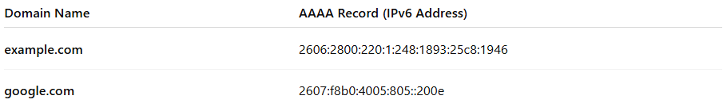
Domain Name | AAAA Record (IPv6 Address)
example.com | 2606:2800:220:1:248:1893:25c8:1946
google.com | 2607:f8b0:4005:805::200e

✅ Summary
# Source: Chatgpt (GPT-5-Mini) at [1/18/2026]
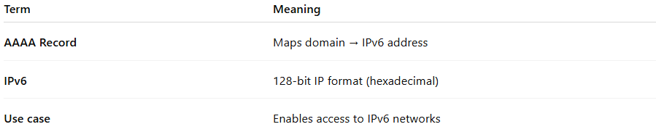

Term | Meaning
AAAA Record | Maps domain → IPv6 address
IPv6 | 128-bit IP format (hexadecimal)
Use case | Enables access to IPv6 networks

